Precision is the proportion of predicted leave takers that actually did take leave. Exhibit X shows the precision of each method’s leave taking predictions. In this model’s context, precision should be thought about as how reliable the model’s leave taking predictions are. Random draws would get about 72% of the leave taking by chance alone. Every model except logit scores appreciably better than this. Naïve Bayes is the next lowest precision score with 75% precision. The remaining four models score around 78-79%. Again, we see the available characteristics provide some predictive power, but still a large portion of predictions remain incorrect, and the improvements over random precision are relatively small.

**Exhibit 8.**

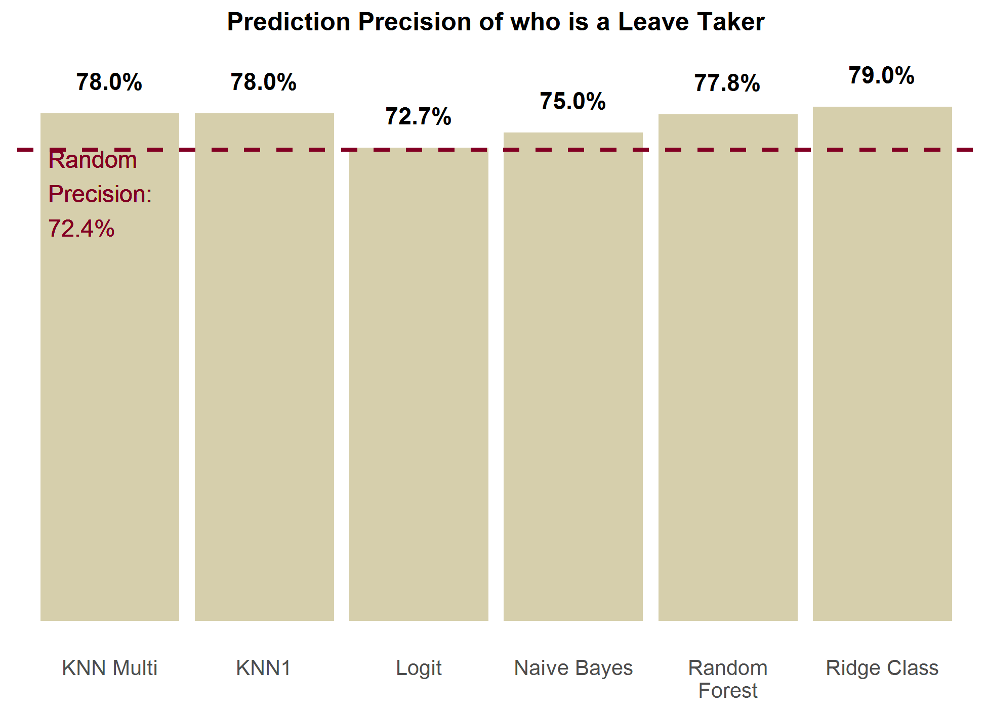

Recall is the proportion of actual leave takers predicted by the model to take leave. Exhibit X is an illustration the recall of each method.

**Exhibit 9.**

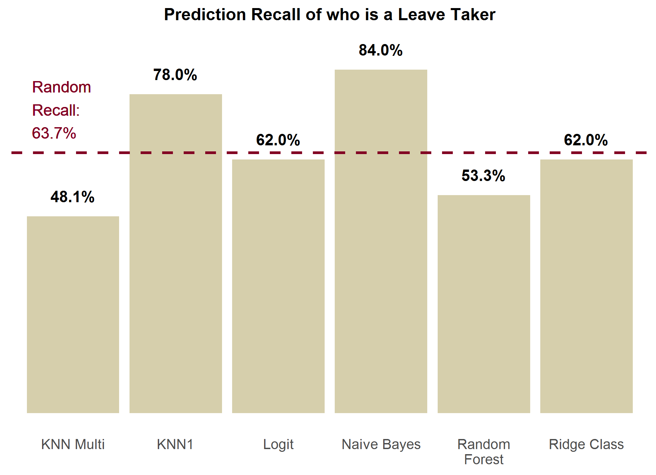

We tested the aggregate predictions for two other variables that are imputed by the model: the proportion of pay received while on leave from employer, and leave needing. We cover these results in the next two sections.

# Appendix X. Testing Methodology Details

## Challenges

The design of FMLA to FMLA predictive testing is tricky for leave taking variables, because the variables our model predicts, and the observable variables in the FMLA data set are different. We try to predict the value of 6 dummy variables for leave taking of each leave type with our model; which can result in more than one type taken being predicted. However, in FMLA, while we know how many leave types an individual took, we can only unbiasedly observe the type for the most recent leave. This problem is illustrated below in Exhibit X.

**Exhibit X. Addressing Issue with Unobservable Leave Taking**

Leave taking observed in FMLA data

|  |  |  |  |  |  |  |
| --- | --- | --- | --- | --- | --- | --- |
| **Individual** | **Take own** | **Take bond** | **Take matdis** | **Take illchild** | **Take illspouse** | **Take illparent** |
| A | 1 | ? | ? | ? | ? | ? |

Leave taking as predicted by model

|  |  |  |  |  |  |  |
| --- | --- | --- | --- | --- | --- | --- |
| **Individual** | **Take own** | **Take bond** | **Take matdis** | **Take illchild** | **Take illspouse** | **Take illparent** |
| A | 1 | 0 | 0 | 0 | 0 | 1 |

Since we only unbiasedly observe with certainty that individual A takes an own leave, we will separately predict whether the observed leave is predicted, penalized by the number of leaves predicted (to account for predicting the correct leave type by chance). This penalty is enforced by comparing results to random draws with the same number of leave types predicted by the model for each individual, and adjusting for the performance of random draws. Second, we test the performance of the model at predicting no leave taking versus any leave taking.